**Project 1: Ordination**

This goal of this project is to assess your ability to perform two of the ordination analyses we have covered in class.

1. **Principal Components Analysis (PCA) of the *Darlingtonia* data set using the R function *princomp*.**

Please answer the following questions based on PCA of the *Darlingtonia* data set. Standardize the data set using z-scores.

1. Based on a scree plot, how many PCA axes should you retain? 2
2. Based on the Latent Root Criterion, how many PCA axes should you retain?3
3. What percentage of the total variation in pitcher morphology is accounted for by the first two PCA axes? ~70%
4. What 3 variables have the largest loading on PCA 1? wingarea, hoodarea, wing1_length
5. What 3 variables have the largest loading on PCA 2? keeldiam, tubediam, wingsprea
6. Make a biplot of the first two PCA axes (attach to your submission)

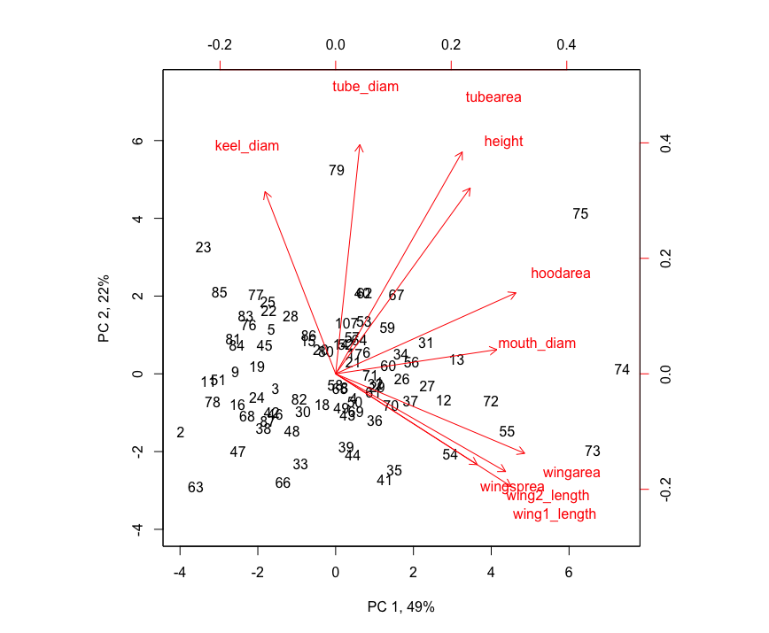

1. In one sentence, how would you describe the morphology of pitcher sample 63? Pitcher sample 63 has a small pitcher by all measured variables.
2. In one sentence, how would you describe the morphology of pitcher sample 75? On the other hand, pitcher sample 75 has a large pitcher by all measured variables.
3. If you could rename each axis in your biplot to describe the variation they explain, what would you name them? (Don’t just pick the name of the variable that has the highest factor loading)?

I would rename the axes “Tube size” and “Wing size.”

1. Now that you have a handle on variation in pitcher morphology for Darlington, describe a research question you could ask using the PCA axes?

How does pitcher morphology affect fitness? We could measure a proxy like age, size, flower, or fruit production. or even follow offspring success with genetics.

1. **Non-metric multi-dimensional (NMDS) analysis of Atlantic and Caribbean island bird communities using the *metaMDS* function in *R.***

Please answer the following questions based on NMDS of the *Atlantic_Caribbean* data set. Use the Jaccard index as a distance measure.

1. What is the stress value for the NMDS of the island bird communities? 0.09867104
2. Based on this stress value, how well does the ordination represent the original distances?

This ordination represents the original distances slightly better than fairly, but not excellently.

1. Plot the NMDS using 2 axes and color the islands based on their ocean. Attach the plot to your submission.

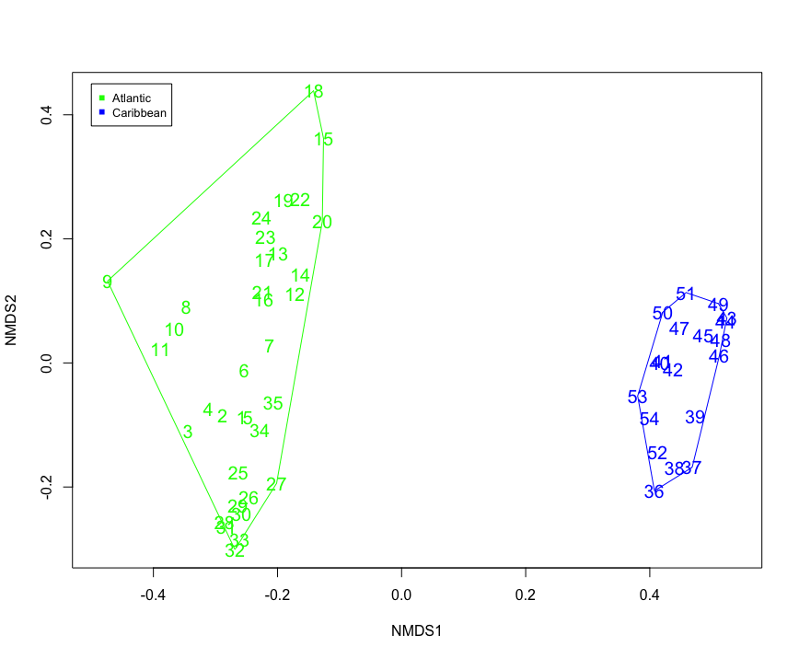

1. What do the results of your NMDS suggest?

The results suggest that the bird communities are distinct in islands of the Atlantic and Caribbean. Within those oceans, the bird communities are similarly nested within archipelagos. In other words, birds dispersal is restricted to by ocean distance between islands.

1. Plot the NMDS using 2 axes and color the islands based on their archipelago. Attach the plot to your submission.

